Wedding Party Menu
2019 Weddings
Below is a list of services needed to ensure,
the Perfect Happily Ever After!

Trials

Trial Bridal Updo: $90.00

Trial Bridal Makeup (Traditional): $50.00

Trial Airbrush Makeup: $75.00

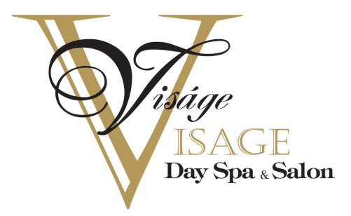

The Day of

Brides Updo: $100.00

Bridal Style with no pinning: $65.00

Attendee Updo: $85.00
(Any sort of pinning is considered an Attendee Updo)

Flower Girl's Updo: $40.00
(Price shown above is valid for 10years and under)

Traditional Makeup Application: $60.00

Airbrush Makeup Application: $85.00

Lash Application (includes lashes): $15.00

Blowouts: $50.00
(Washed and blown out straight - no irons)

Please be advised that a
20 % Gratuity will be added to each party
(prices shown above are valid Monday-Saturday)

Visage A' Visage Day Spa and Salon at The Mansion
802 North Duke Street, Lancaster PA 17602
717-299-5315
www.visageavisage.com

